/var/folders/z8/vdfp4_yj08sgjyy_yyk9q5h40000gp/T/com.apple.Preview/com.apple.Preview.PasteboardItems/re_colossiansstencils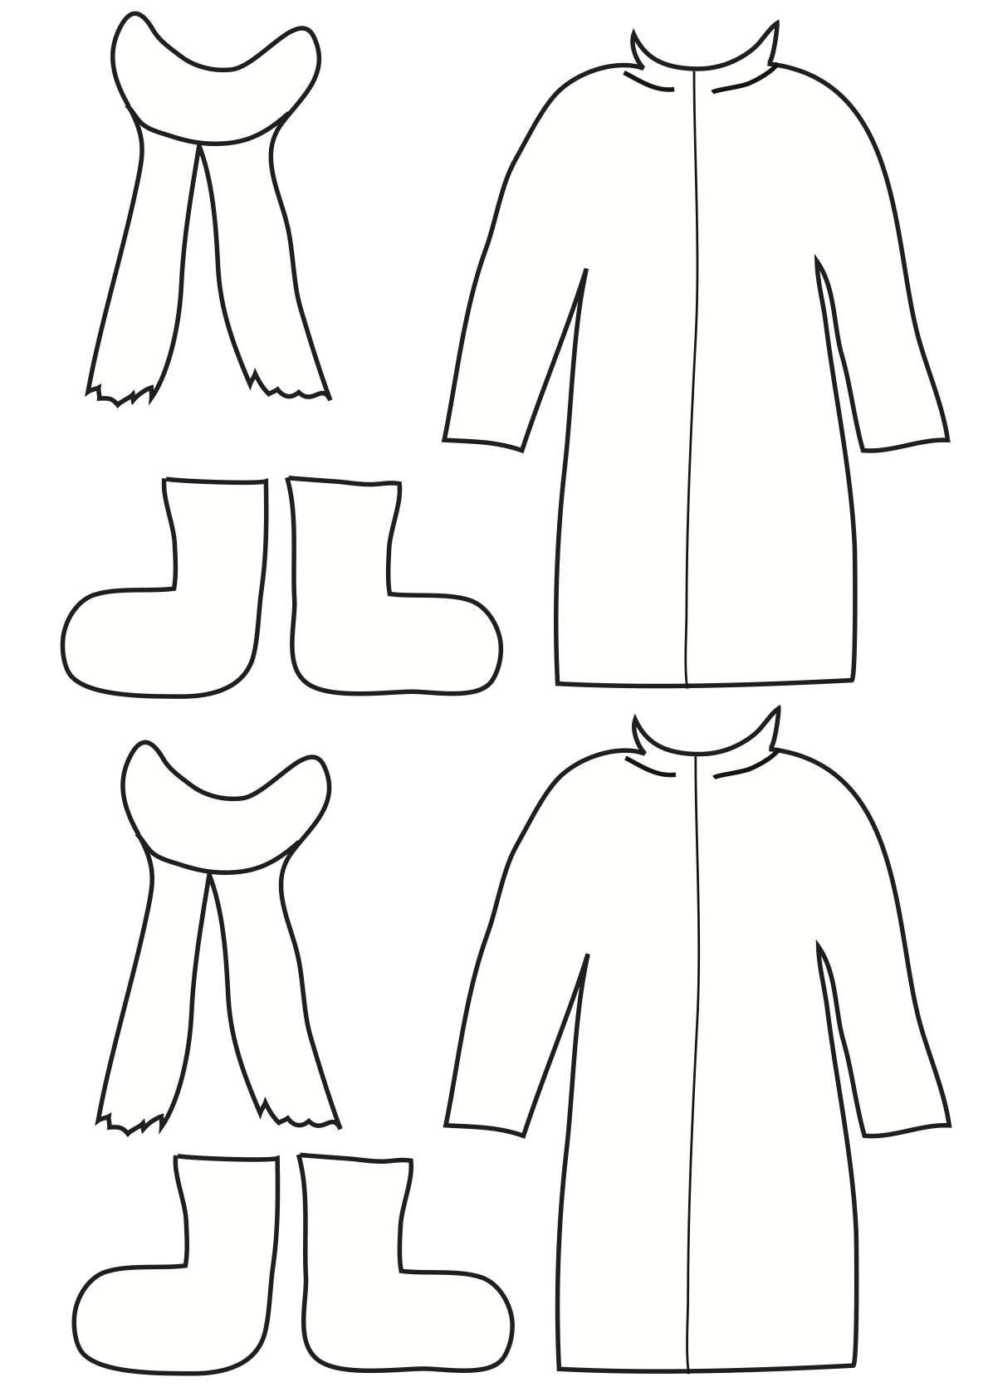

f
